AI-Powered Sympton Checker and Diet Recommender
Author: Neelam Pramod Pawar
Date: 2025-11-05
Executive Summary:
The Health Symptom Checker and Diet Recommender is an AI-driven system that uses multi-agent collaboration to analyze user symptoms, suggest possible health conditions, and recommend personalized diet plans. Built using CrewAI, LangGraph, and OpenRouter/OpenAI APIs, the project integrates four specialized agents—Symptom, Diagnosis, Diet, and Report—to create an intelligent healthcare workflow that mimics real-world medical reasoning.
With a Streamlit-based interface for seamless user interaction and LLM-powered logic for accurate responses, the system aims to make preliminary health insights and nutrition guidance more accessible, laying the foundation for future integration with real medical data and wearable health devices.
Project Github Link:
https://github.com/Neelu10/EY_AI_Tasks_and_Training/tree/master/5_11_25

INDEX

Table of Contents | Page No
Problem Statement | 1
Objectives and Scope | 1
Architecture | 2
Technology Stack | 3
System Design | 3
Implementation | 4
Deployment & Running | 5
Testing and Validation | 6
Future Improvements | 6
Security, Privacy and Cost | 6
References | 6
Appendix | 7

- Problem Statement:
Many individuals struggle to understand the underlying causes of their health symptoms and often lack access to quick, reliable, and personalized dietary advice. This leads to confusion, delayed care, and unhealthy lifestyle choices. The Health Symptom Checker and Diet Recommender aims to address this problem by using AI-powered multi-agent collaboration to analyze user-reported symptoms, suggest potential common health conditions, and generate customized diet recommendations, thereby promoting informed and proactive health management.

- Objectives:
- To develop an AI-powered system that analyzes user-input symptoms and identifies possible common health conditions.
- To design a multi-agent framework (Symptom, Diagnosis, Diet, and Report Agents) that collaborates intelligently to generate accurate and personalized outputs.
- To recommend safe and customized diet plans aligned with the identified health insights.
- To create an interactive and user-friendly Streamlit interface for seamless symptom entry and report visualization.
- To demonstrate the practical use of CrewAI and LangGraph in building real-world, healthcare-focused intelligent systems.

- Scope:
- The project focuses on developing an AI-based multi-agent system for analyzing symptoms and providing personalized diet recommendations.
- It emphasizes general wellness and preventive care, not medical diagnosis, ensuring safe and ethical AI use.
- The system integrates CrewAI, LangGraph, and Streamlit to create a scalable, modular, and interactive platform.
- It enables real-time health insights and personalized dietary suggestions through intelligent agent collaboration.
- The scope can be extended to include integration with verified medical databases, user health records, and wearable device data in the future.

- Architecture:
Architecture Overview
1. User Interface Layer (Streamlit)
• Users input symptoms, allergies, and preferences.
• Displays health insights and personalized diet plans.
2. Backend Logic (CrewAI Agents + LangGraph)
• SymptomAgent → Extracts and interprets health symptoms.
• DiagnosisAgent → Maps symptoms to possible conditions.
• DietAgent → Generates safe diet plans based on diagnosis.
• ReportAgent → Compiles final health report and recommendations.
• Agents communicate through CrewAI’s workflow engine (LangGraph handles flow logic).
3. LLM Integration (OpenAI / Hugging Face / Gemini, etc.)
• Provides natural language understanding and reasoning capabilities for symptom interpretation and recommendation generation.
4. Data Layer (Optional Extensions)
• Could include a SQLite / MongoDB database to store user sessions, reports, or past health logs.
• External APIs like Nutritionix, Healthline, or Mayo Clinic datasets for verified dietary and symptom data.
2) Diagram:

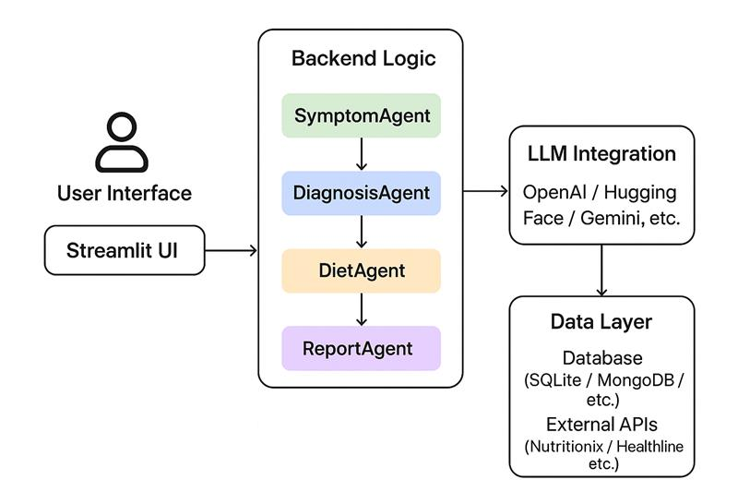

- Technology Stack:
• Frontend: Streamlit
• Backend: Python (CrewAI + LangGraph)
• LLM: OpenAI GPT / HuggingFace model
• Database (Optional): SQLite / MongoDB
• Libraries: pandas, requests, crewai, langgraph, streamlit

- System Design:
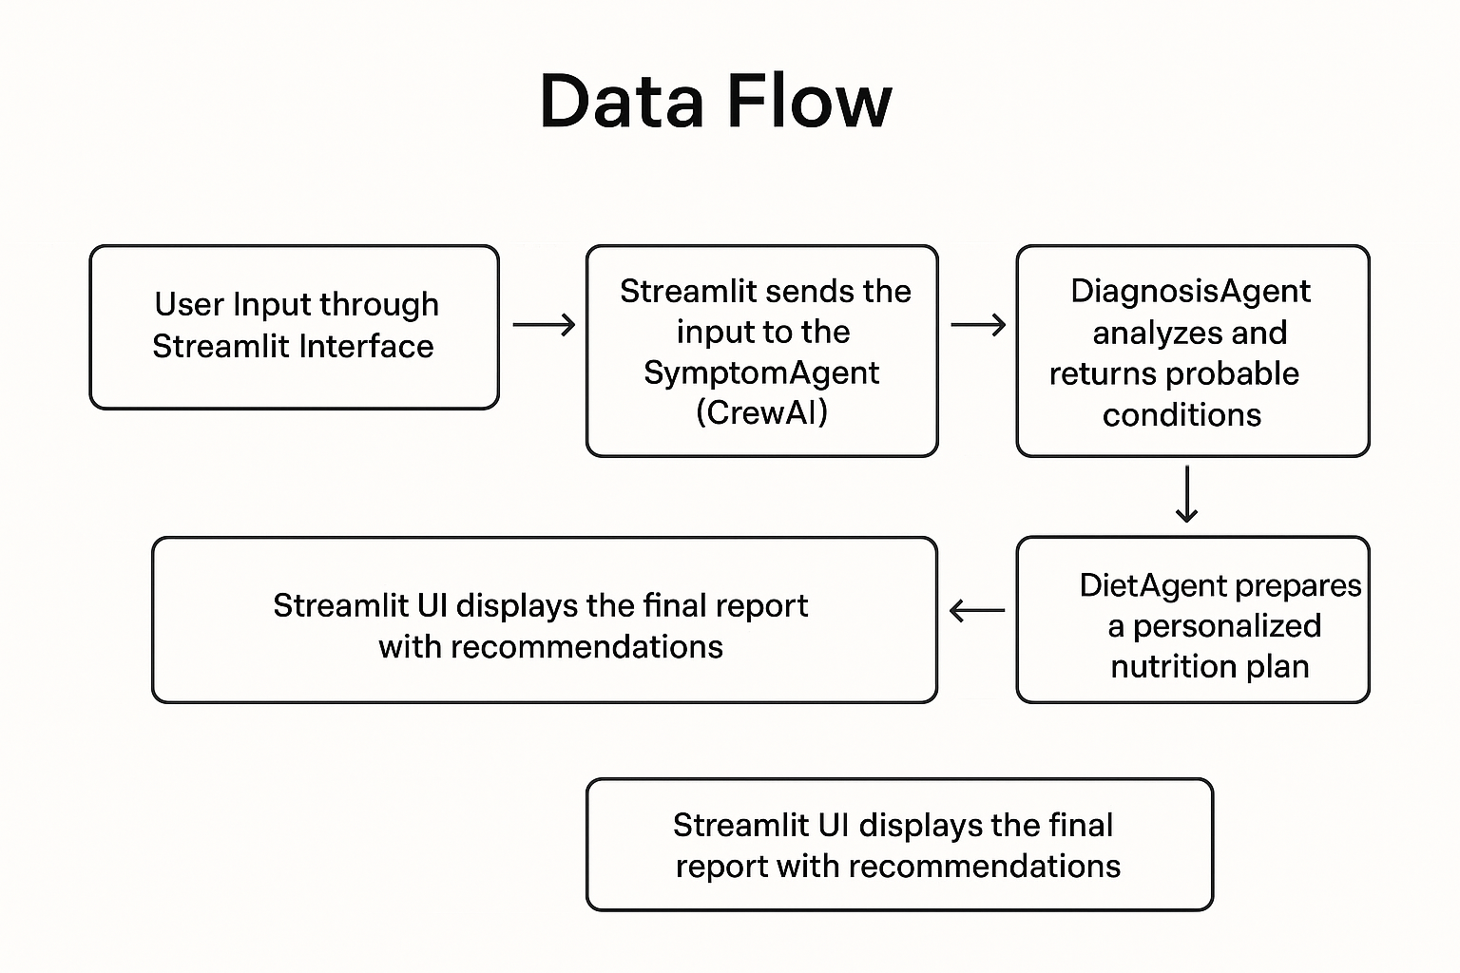
1)Data flow:

- User Input through Streamlit Interface
The user begins by entering their observed symptoms, how long they have been experiencing them, and the severity level into the Streamlit application. This interface acts as the front-end layer where all user interactions take place.
- Streamlit Sends the Input to the SymptomAgent (CrewAI)
Once the user submits the form, Streamlit forwards these details to the SymptomAgent. This agent is responsible for interpreting the user input, understanding the context, and preparing it for medical reasoning.
- DiagnosisAgent Evaluates the Symptoms
The SymptomAgent then collaborates with the DiagnosisAgent. The DiagnosisAgent analyzes the symptom patterns, compares them to known medical conditions, and identifies possible health issues. The output of this stage is a probable diagnosis based on the provided symptom data.
- DietAgent Prepares a Personalized Nutrition Plan
After the diagnosis is generated, the information is passed to the DietAgent. This agent creates a customized diet plan that aligns with the potential health condition. It considers meal balance, nutritional intake, lifestyle requirements, and foods that could either improve or worsen the health condition.
- ReportAgent Composes the Final Summary
The ReportAgent gathers all the results from the DiagnosisAgent and DietAgent and compiles them into a structured report. This report explains the suspected health condition in simple language and provides lifestyle recommendations along with the diet suggestions.
- Streamlit Displays the Final Output to the User
The final combined report is presented back to the user through the Streamlit interface. It includes the probable diagnosis, recommended diet plan, and overall wellness guidance. The user can read, save, or download the report for personal use.

The system works by taking user inputs (symptoms, duration, and severity) through the Streamlit interface and passing them into the LangGraph workflow. Inside the workflow, the SymptomAgent first interprets and structures the input. The DiagnosisAgent then analyzes the symptoms and provides probable health conditions. Next, the DietAgent creates a personalized nutrition plan based on the diagnosis. Finally, the ReportAgent compiles everything into an easy-to-understand health summary. The completed report is stored in the health_reports table using consistent field names such as symptoms, duration, severity, diagnosis, diet, and report, ensuring smooth data handling across the UI, model, and database.

- Implementation:
1)Folder Structure:
Health-Symptom-Checker-and-Diet-Recommender/
│
├── agents/
│ ├── __init__.py
│ ├── symptom_agent.py
│ ├── diagnosis_agent.py
│ ├── diet_agent.py
│ ├── report_agent.py
│
├── workflow/
│ ├── health_workflow.py
│ ├── app
│ ├── database. Py
├── .env
├── pdf.generator.py
├── requirements.txt
├── main.py
|_

2)Key module responsibilities:
1. Streamlit UI (app.py):
- Collects user inputs (symptoms, duration, severity).
- Sends input to the LangGraph workflow for processing.
- Displays the diagnosis, diet recommendations, and summary.
- Handles PDF download and displays previously saved reports.

2. Workflow Module (health_workflow.py):
- Builds and executes the LangGraph pipeline.
- Orchestrates communication between the SymptomAgent, DiagnosisAgent, DietAgent, and ReportAgent.
- Ensures smooth data flow through each stage of analysis.

3. Agents Module (Inside Workflow):
- SymptomAgent: Interprets symptom descriptions and prepares structured input.
- DiagnosisAgent: Suggests possible medical conditions based on the symptoms.
- DietAgent: Generates a personalized meal/diet recommendation aligned with the diagnosis.
- ReportAgent: Compiles final insights into a concise and user-friendly health summary.

4. Database Module (database.py):
- Initializes and manages the SQLite database.
- Saves generated reports for future reference.
- Retrieves and returns stored report history for display in the UI.

5. PDF Generator (pdf_generator.py):
- Converts the generated report into a clean, downloadable PDF.
- Ensures formatted structure and organized presentation.

3)Example code snippets:
Streamlit ui app
symptoms = st.text_area("Symptoms")
if st.button("Generate Report"):
result = health_graph.invoke({"input": symptoms})
st.write(result["diagnosis"])

Workflow creation
def create_health_graph():
return Graph(symptom_agent, diagnosis_agent, diet_agent, report_agent)

- Deployment & Running:
1)Prerequisites:
- Python 3.11+
- OpenAI or OpenRouter resource with chat & embedding deployments
- Pycharm (recommended)
- Langchain
- langgraph

2)Environment variables:
See Appendix for .env sample. Place .env in project root.

3)Install:
python -m venv venv
source venv/bin/activate # or .\venv\Scripts\activate (Windows)
pip install -r requirements.txt

4)Run:
python main.py
streamlit run app.py

I)Testing and Validation:
The system is tested using a combination of unit tests, integration tests, and manual user scenario testing.
- Unit tests validate individual modules such as symptom interpretation, diet suggestion logic, and database operations.
- Integration testing ensures agents communicate properly in the workflow and return consistent structured outputs.
- User validation is done by comparing generated recommendations with medically reliable sources to confirm logical accuracy and relevance.

- Future Improvements:
The system can be enhanced by integrating medical knowledge graphs, real electronic health record (EHR) datasets, and live symptom trend monitoring. A chatbot-style conversational interface may be added for continuous guidance. Future versions may also include multilingual support, wearable device data integration, and doctor teleconsultation linkage for more accurate, real-time and personalized health recommendations.

- Security, Privacy & Cost:
The system stores only essential user health inputs and recommendations, avoiding personally identifiable information to maintain privacy. Data is stored locally using SQLite, and access is controlled within the application to prevent unauthorized retrieval. No external health databases are contacted unless explicitly added, ensuring user confidentiality.
Cost primarily depends on the usage of the AI model. Running lightweight models locally or using open-source alternatives can reduce expenses, while cloud-based and higher-capacity models may increase operational cost. Overall, the system remains low-cost and secure, with privacy preserved by design.

- References:
- OpenAI docs
- LangGraph / LangChain docs
- CrewAI docs
- pandas documentation (read_excel / to_sql)

- Appendix:
1)Sample .env:

OPENAI_API_KEY=your_openai_api_key_here

# (Optional) If using OpenRouter or other providers
OPENROUTER_API_KEY=your_openrouter_key

2) Sample agent schema (example from diagnosis_agent.py):
DiagnosisAgent = Agent(
name="Diagnosis Intelligence Analyst",
role="Medical Condition Reasoning Agent",
goal=(
"Analyze the structured symptoms provided by the SymptomAgent and identify "
"possible common health conditions or causes. "
"Rank these conditions by confidence level (0–100%) and include short explanations "
"based on symptom patterns. Focus only on general wellness insights — "
"avoid making medical diagnoses or prescribing treatments."
),
backstory=(
"You are a medically informed AI analyst trained in symptom pattern recognition. "
"Your role is to logically reason through symptom combinations and map them
),
verbose=True,
allow_delegation=False,
llm=llm()
)

3) Sample prompts:
=prompt:
Symptons={}
Duration={}
Severity level={}

Follow-up prompt for explanation:
Symptons={fever,fatigue,tiredness}
Duration={4 days}
Severity level={moderate}

Ai powered Symptom checker and Diet recommender UI:

